THEORY OF COMPUTATION
2017–2018 | 1st Midterm — Solved Answers
Paper date shown in scan: 30 October 2022

Question-wise topic map
Part | Topic | Subtopic | Answer focus
A | Formal Languages & Grammars | Chomsky hierarchy | Four grammar types and language classes
B | Finite Automata | DFA for substring 11 | Formal tuple, transition table and diagram
C | Finite Automata | Parity DFA; extended transition | Trace input 110101
D | Finite Automata | Keyword recognition | DFA transition diagram for include
E | Nondeterministic Automata | First symbol occurs again | NFA, transition table and examples

Note on source fidelity: The answers follow the wording visible in the supplied scan. For Part D, the phrase “keyword recognizer occurrences” is interpreted as detecting the word include as a substring in a character stream. The alphabet is therefore the set of input characters.

Question A — marks
Question: Describe the Chomsky hierarchy (occasionally referred to as the Chomsky–Schützenberger hierarchy). Describe all types.
Topic | Formal Languages and Grammars
Subtopic | Chomsky hierarchy; Type 0, Type 1, Type 2 and Type 3 grammars

The Chomsky hierarchy classifies formal grammars and the languages they generate into four levels, from the most general (Type 0) to the most restricted (Type 3). Each lower level is contained in the level above it.

Hierarchy and containment
Regular ⊊ Context-Free ⊊ Context-Sensitive ⊊ Recursively Enumerable
Equivalently: Type 3 ⊂ Type 2 ⊂ Type 1 ⊂ Type 0.

1. Type 0 — Unrestricted grammar
A Type 0 grammar has productions with essentially no restriction on the form of the left-hand side, except that it must contain at least one nonterminal. A production may be written α → β, where α contains at least one variable and β is any string of terminals and/or variables (including ε, subject to the usual grammar convention).
α → β, where α ∈ (V ∪ Σ)* V (V ∪ Σ)*
Language class: recursively enumerable languages. Machine model: Turing machine. A Turing machine recognizes a recursively enumerable language: it accepts members, while on a nonmember it may reject or run forever.

2. Type 1 — Context-sensitive grammar
A Type 1 grammar is non-contracting: a production does not decrease the length of the sentential form. A common form is αAβ → αγβ, where A is a nonterminal and γ is nonempty. The special rule S → ε may be allowed when S does not occur on any right-hand side.
|left side| ≤ |right side|
Language class: context-sensitive languages. Machine model: linear bounded automaton (LBA), a restricted Turing machine whose usable tape is bounded linearly by the input length.

3. Type 2 — Context-free grammar
A Type 2 grammar has a single nonterminal on the left side of every production. The replacement of that nonterminal does not depend on its surrounding context.
A → γ, where A ∈ V and γ ∈ (V ∪ Σ)*
Language class: context-free languages. Machine model: pushdown automaton (PDA), which uses a stack.
Example: S → aSb | ε generates {aⁿbⁿ : n ≥ 0}.

4. Type 3 — Regular grammar
A Type 3 grammar is right-linear or left-linear. In a right-linear grammar, productions have forms A → aB, A → a, and optionally S → ε. A and B are nonterminals, and a is a terminal. Do not mix right-linear and left-linear rules arbitrarily in one grammar.
A → aB or A → a (and optionally S → ε)
Language class: regular languages. Machine model: finite automaton (DFA or NFA); regular expressions describe exactly the same class.

Summary table
Type | Grammar restriction | Language class | Equivalent machine
Type 0 | Unrestricted | Recursively enumerable | Turing machine
Type 1 | Non-contracting / context-sensitive | Context-sensitive | Linear bounded automaton
Type 2 | Single nonterminal on LHS | Context-free | Pushdown automaton
Type 3 | Right-linear or left-linear | Regular | Finite automaton
Key relationship: every regular language is context-free; every context-free language is context-sensitive; and every context-sensitive language is recursively enumerable. The reverse inclusions do not generally hold.

Question B — marks
Question: Let Σ = {0,1}. Develop a DFA and make a transition table for L = {w | w is a bit string which contains the substring 11}.
Topic | Finite Automata
Subtopic | DFA construction for substring/pattern recognition

The language contains all binary strings in which two consecutive 1s occur somewhere. Once the machine has seen 11, it must remain accepting regardless of the remaining input.
L = { w ∈ {0,1}* : 11 is a substring of w }

State meanings
- q₀: no useful trailing 1 has been seen; the current suffix does not end in 1.
- q₁: the most recently read symbol is 1, but 11 has not yet been found.
- q₂: substring 11 has been found; this is the accepting state.

Formal DFA
M = (Q, Σ, δ, q₀, F)
Q = {q₀,q₁,q₂}, Σ = {0,1}, start = q₀, F = {q₂}

Transition table
Current state | Input 0 | Input 1
→ q₀ | q₀ | q₁
q₁ | q₀ | q₂
* q₂ | q₂ | q₂

State diagram
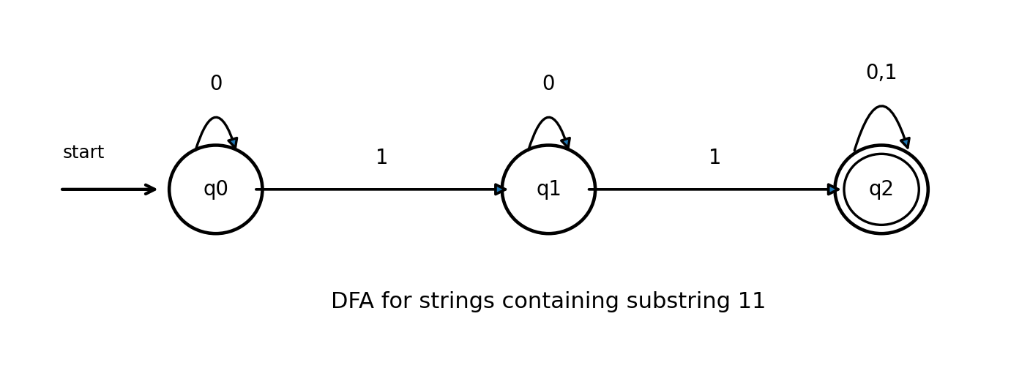

Example
For input 10110: q₀ --1--> q₁ --0--> q₀ --1--> q₁ --1--> q₂ --0--> q₂. The final state is q₂, so 10110 is accepted.
For input 10101, the machine never reads two consecutive 1s; it finishes in q₁, so it is rejected.

Question C — marks
Question: Let Σ = {0,1}. A DFA for L = {w | w is a binary string that has even number of 1s and even number of 0s}. Let the string 110101. Calculate the extension of transition to paths.
Topic | Finite Automata
Subtopic | Parity DFA; extended transition function δ*

The required DFA records whether the number of 1s is even or odd and whether the number of 0s is even or odd. Use the state notation XY, where X is parity of 1s and Y is parity of 0s.
- EE: even 1s, even 0s (start and accepting).
- OE: odd 1s, even 0s.
- EO: even 1s, odd 0s.
- OO: odd 1s, odd 0s.
Q={EE,OE,EO,OO}, Σ={0,1}, q₀=EE, F={EE}

Transition table
State | Input 0 | Input 1
→ *EE | EO | OE
OE | OO | EE
EO | EE | OO
OO | OE | EO

Extended transition function
The extended transition function δ* processes an entire string. Its recursive definition is:
δ*(q, ε) = q
δ*(q, xa) = δ(δ*(q,x), a), where x ∈ Σ* and a ∈ Σ

Calculate δ*(EE, 110101)
Process the input one symbol at a time:
Step | Symbol read | State before | State after
0 | — | — | EE (start)
1 | 1 | EE | OE
2 | 1 | OE | EE
3 | 0 | EE | EO
4 | 1 | EO | OO
5 | 0 | OO | OE
6 | 1 | OE | EE
EE --1--> OE --1--> EE --0--> EO --1--> OO --0--> OE --1--> EE
Therefore, δ*(EE, 110101) = EE
The string 110101 contains four 1s and two 0s. Both counts are even, so it is accepted by the DFA.

Question D — marks
Question: For the keyword recognizer occurrences of the word “include”, make a transition diagram.
Topic | Finite Automata
Subtopic | Keyword recognition; DFA for detecting a fixed word

Interpretation: read a stream of characters and recognize when the consecutive keyword include occurs. The DFA tracks how much of the keyword has been matched as a suffix of the input read so far.
Keyword = i n c l u d e

States
q₀ means no prefix of “include” is currently matched. q₁ through q₆ mean the input currently ends with the first 1 through 6 letters of the keyword. q₇ means the complete keyword has been recognized and is accepting.

Transition rule
- From q₀, input i moves to q₁; any other character stays at q₀.
- From q₁, expected n moves to q₂. From q₂, expected c moves to q₃; then l, u, d and e advance one state at a time.
- A mismatching character resets the match to q₀, except that if the mismatching character is i, the machine goes to q₁ because a new keyword may start there.
- After reaching q₇, the keyword has been detected. For continued scanning, a subsequent i can start a new match at q₁; any other character returns to q₀.

Transition diagram
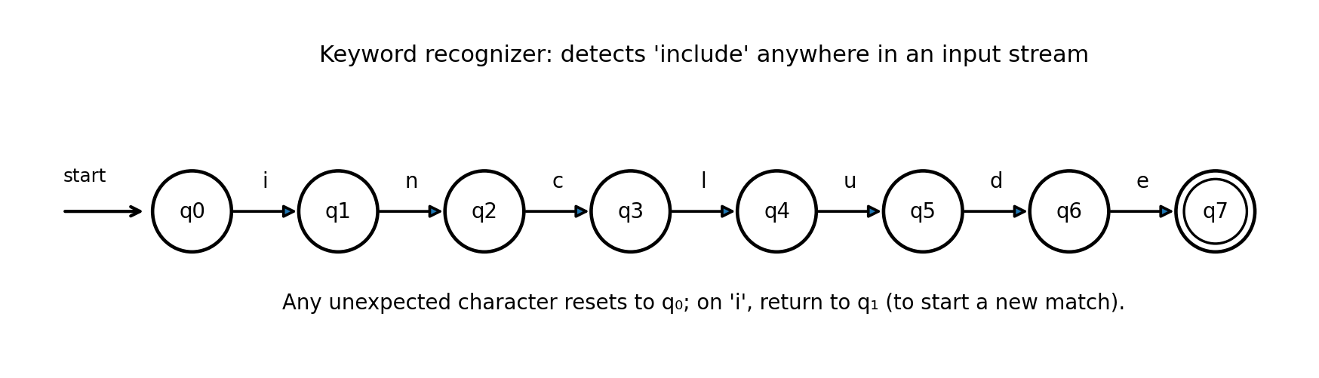
The diagram shows the matching path q₀ → q₁ → … → q₇. Each forward edge is labeled with the next required character. The mismatch/reset rule is stated above to avoid drawing many overlapping reset arrows.

Compact transition table
State | Expected input | Next state
q0 | i | q1
q1 | n | q2
q2 | c | q3
q3 | l | q4
q4 | u | q5
q5 | d | q6
q6 | e | q7
q₇ | i | q₁
For all states, a nonmatching character other than i goes to q₀; on i, the machine goes to q₁. The q₇ row describes continued scanning after a match.

Example
Input: “please include this”. While reading the characters, the automaton reaches q₇ immediately after reading the e in include, so the keyword is recognized.

Question E — marks
Question: Make an NFA: strings where the first symbol is present somewhere later on at least once.
Topic | Nondeterministic Finite Automata
Subtopic | NFA construction; first symbol reappears later in the string

Interpretation: a nonempty input string is accepted if its first symbol occurs at least one more time after the first position. The scan uses Σ={0,1}, matching the alphabet used in the other automata questions.
L = {w ∈ {0,1}⁺ : if w=ax, then a occurs in x}

State meanings
- q₀: start state; no symbol has been read yet.
- p₀: first symbol was 0; search for another 0.
- p₁: first symbol was 1; search for another 1.
- qf: a later matching symbol has been found; accepting state.
Q={q₀,p₀,p₁,qf}, Σ={0,1}, start=q₀, F={qf}

NFA transition table
State | Input 0 | Input 1
q₀ | {p₀} | {p₁}
p₀ | {p₀,qf} | {p₀}
p₁ | {p₁} | {p₁,qf}
qf | {qf} | {qf}
The nondeterministic choice occurs when the matching symbol is read: the NFA may remain in its search state or move to qf. This lets it guess that the current symbol is the later occurrence.

NFA state diagram
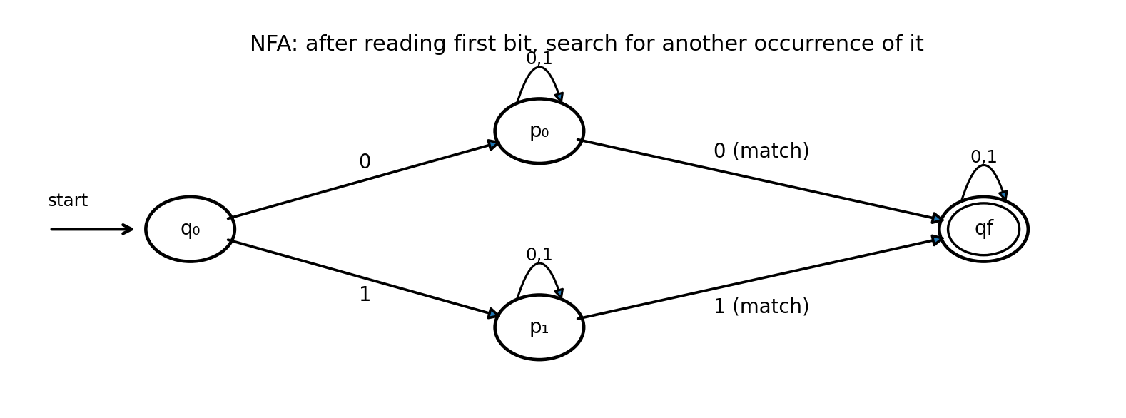

Examples
Accepted: 010. The first symbol is 0 and it appears again at the third position. A path is q₀ → p₀ → p₀ → qf.
Rejected: 011. The first symbol 0 never appears again, so qf cannot be reached.
General form for any finite alphabet Σ: create a state pₐ for each a∈Σ. From q₀, input a enters pₐ. In pₐ, loop on every symbol of Σ and also branch to qf on a. State qf loops on every symbol.

